Team members Name | Mail Id
Abinaya. K | abinayak2020@gmail.com
Dhanalakshmi. S | dhanalakshmisekar26@gmail.com
Mahalakshmi. R | maha606105@gmail.com
Kokila .M | kokila071004@gmail.com

Market Basket Insights


Introduction:
Market basket analysis is a data mining technique used in association rule learning to discover patterns and relationships between items that are frequently purchased together in a transaction or "basket." It's commonly used in retail and e-commerce to gain insights into customer behavior and optimize strategies like cross-selling and product placement.

Apriori Algorithm:
One of the fundamental association learning rules used in market basket analysis is the Apriori algorithm. The Apriori algorithm identifies associations between items by finding frequent item sets and generating rules based on these item sets.
Dataset from: https://www.kaggle.com/datasets/aslanahmedov/market-basket-analysis

1) Import Libraries

In [1]:
import pandas as pd
import numpy as np
from mlxtend.frequent_patterns import apriori, association_rules
import plotly.express as px

2) Data Pre-processing

In [2]:
df_ = pd.read_csv("../input/market-basket-analysis/Assignment-1_Data.csv", sep = ";")
df = df_copy()
/opt/conda/lib/python3.7/sitepackages/IPython/core/interactiveshell.py:344: DtypeWarning: Columns (0) have mixed types.Specify dtype option on import or set low_memory=False.
exec (code_obj, self.user_global_ns, self.user_ns)
In [4]:
df.head(10)
In [4]:
def check_df(dataframe, head=5):
print("##################### Shape #####################")
print(dataframe.shape)
print("##################### Types #####################")
print(dataframe.dtypes)
print("##################### Head #####################")
print(dataframe.head(head))
print("##################### Tail #####################")
print(dataframe.tail(head))
print("##################### NA #####################")
print(dataframe.isnull().sum())
In [5]:
check_df(df)
##################### Shape #####################
(522064, 7)
##################### Types #####################
BillNo object
Itemname object
Quantity int64
Date object
Price object
CustomerID float64
Country object
dtype: object
##################### Head #####################
BillNo Itemname Quantity Date \
0 536365 WHITE HANGING HEART T-LIGHT HOLDER 6 01.12.2010 08:26
1 536365 WHITE METAL LANTERN 6 01.12.2010 08:26
2 536365 CREAM CUPID HEARTS COAT HANGER 8 01.12.2010 08:26
3 536365 KNITTED UNION FLAG HOT WATER BOTTLE 6 01.12.2010 08:26
4 536365 RED WOOLLY HOTTIE WHITE HEART. 6 01.12.2010 08:26
Price CustomerID Country
0 2,55 17850.0 United Kingdom
1 3,39 17850.0 United Kingdom
2 2,75 17850.0 United Kingdom
3 3,39 17850.0 United Kingdom
4 3,39 17850.0 United Kingdom
##################### Tail #####################
BillNo Itemname Quantity Date \
522059 581587 PACK OF 20 SPACEBOY NAPKINS 12 09.12.2011 12:50
522060 581587 CHILDREN'S APRON DOLLY GIRL 6 09.12.2011 12:50
522061 581587 CHILDRENS CUTLERY DOLLY GIRL 4 09.12.2011 12:50
522062 581587 CHILDRENS CUTLERY CIRCUS PARADE 4 09.12.2011 12:50
522063 581587 BAKING SET 9 PIECE RETROSPOT 3 09.12.2011 12:50
Price CustomerID Country
522059 0,85 12680.0 France
522060 2,1 12680.0 France
522061 4,15 12680.0 France
522062 4,15 12680.0 France
522063 4,95 12680.0 France
##################### NA #####################
BillNo 0
Itemname 1455
Quantity 0
Date 0
Price 0
CustomerID 134041
Country 0
dtype: int64

In [6]:
# Drop an values
df.dropna(in place=True)
# Quantity and Price should be greater than 0
df = df[df["Quantity"] > 0]
# We have to change the price column datatype as a numeric
df ['Price'] = pd.to_numeric(df['Price'], errors='coerce')
df = df[df["Price"] > 0]
In [7]:
check_df(df)
##################### Shape #####################
(1537, 7)
##################### Types #####################
BillNo object
Itemname object
Quantity int64
Date object
Price float64
CustomerID float64
Country object
dtype: object
##################### Head #####################
BillNo Itemname Quantity Date \
45 536370 POSTAGE 3 01.12.2010 08:45
237 536392 RUSTIC SEVENTEEN DRAWER SIDEBOARD 1 01.12.2010 10:29
377 536403 POSTAGE 1 01.12.2010 11:27
1113 536527 POSTAGE 1 01.12.2010 13:04
4348 536779 Bank Charges 1 02.12.2010 15:08
Price CustomerID Country
45 18.0 12583.0 France
237 165.0 13705.0 United Kingdom
377 15.0 12791.0 Netherlands
1113 18.0 12662.0 Germany
4348 15.0 15823.0 United Kingdom
##################### Tail #####################
BillNo Itemname Quantity Date Price CustomerID \
521357 581493 POSTAGE 1 09.12.2011 10:10 15.0 12423.0
521375 581494 POSTAGE 2 09.12.2011 10:13 18.0 12518.0
521885 581570 POSTAGE 1 09.12.2011 11:59 18.0 12662.0
521922 581574 POSTAGE 2 09.12.2011 12:09 18.0 12526.0
521923 581578 POSTAGE 3 09.12.2011 12:16 18.0 12713.0
Country
521357 Belgium
521375 Germany
521885 Germany
521922 Germany
521923 Germany
##################### NA #####################
BillNo 0
Itemname 0
Quantity 0
Date 0
Price 0
CustomerID 0
Country 0
dtype: int64

3) Exploratory Data Analysis and Some Visualizations

In [8]:
linkcode
total_sales = df
total_sales["Total_Price"] = total_sales["Price"] * total_sales["Quantity"]
#total_sales.columns
total_sales_per_customer = total_sales.groupby(["CustomerID", "Country"]).agg({"Total_Price": "sum"})
total_sales_per_customer.head(10)

Top 10 Shoppers and Their Coutries

In [9]:
linkcode
total_sales_per_customer.reset_index(in place=True)
total_sales_per_customer.sort_values(by = "Total_Price", ascending = False)head(10)

# consider that for all time period
data_fig = total_sales_per_customer.sort_values(by = "Total_Price", ascending = False).head(100)
fig = px.scatter(data_fig, x="CustomerID", y="Total_Price",
size="Total_Price", color="Country",
hover_name="Country", log_x=True, size_max=60, title="Top 100 Shoppers and Their Contries & Shopping Amounts")
fig.show()

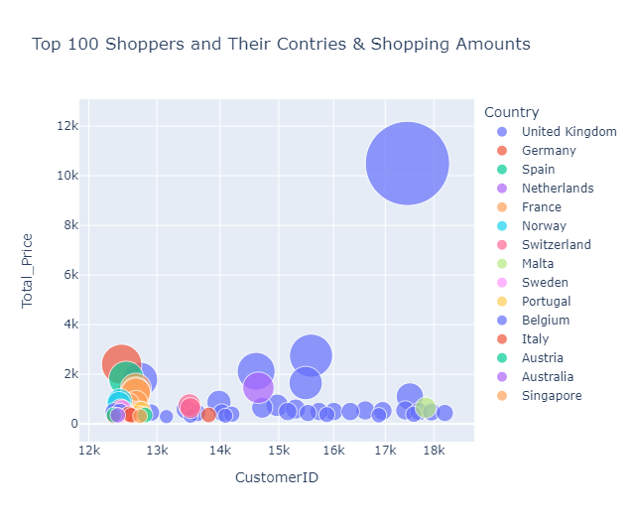

In [10]:
#Consider that for all time period
#total_sales_per_customer. head (20)
total_sales_per_customer.groupby(["Country"]).agg({"Total_Price":"sum"}).reset_index().sort_values(by="Total_Price", ascending=False)

In [11]:
# consider that for all time period
data = total_sales_per_customer.groupby(["Country"]).agg({"Total_Price":"sum"})._index().sort_values(by="Total_Price", ascending=False )
fig = px.bar(data, x='Country', y='Total_Price' , title = "Shopping Amounts by Countries")
In [12]:
fig.show()

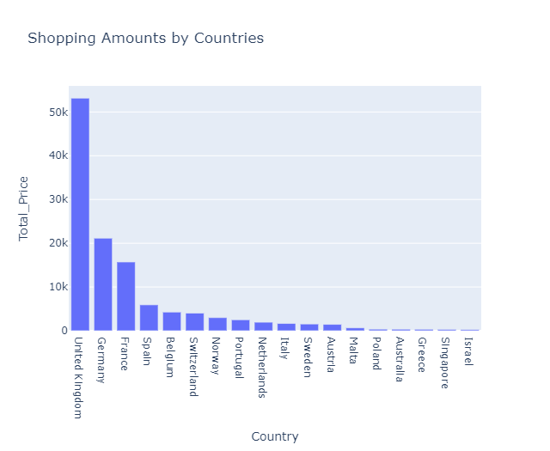

4) Invoice Product Matrix

In [13]:
Linkcode:
#df_united_kingdom = df.loc[df["Country"[=="United Kingdom"]
df_invoice_product_matrix = df.groupby(['BillNo', 'Itemname']). \
agg({"Quantity": "sum"}) unstack().fillna(0). \
applymap(lambda x: 1 if x > 0 else 0)
df_invoice_product_matrix.head(10)

5) Association Rules Learning

In [14]:

linkcode
frequent_itemsets = apriori(df_invoice_product_matrix, min_support=0.001, use_colnames=True)
frequent_itemsets.sort_values("support", ascending=False)

In [15]:

rules = association_rules(frequent_itemsets, metric="support", min_threshold=0.001)
rules.sort_values("support", ascending=False). head (10)

In [16]:

sorted_rules = rules.sort_values("lift", ascending=False)
rules.sort_values("lift", ascending=False). head (10)

In [17]:

# We can try below products in the loop
# ('Quantity', 'VANILLA SCENT CANDLE JEWELLED BOX')
# ('Quantity', 'DOORMAT MERRY CHRISTMAS RED')
# ('Quantity', 'DOORMAT RESPECTABLE HOUSE')
# ('Quantity', 'DOORMAT SPOTTY HOME SWEET HOME')
# ('Quantity', 'DOORMAT UNION FLAG')
# ('Quantity', 'DOORMAT UNION FLAG')
recommendation_list = []
for i, product in sorted_rules["antecedents"].items():
for j in list(product):
if j == ('Quantity', 'MARIE ANTOINETTE TRINKET BOX GOLD'):
recommendation_list.append(list(sorted_rules.iloc[i]["consequents"]))

In [18]:

recommendation_list
Conclusion:
In conclusion, the Market Basket Insight project has provided valuable insights into customer purchasing patterns and product associations. Through data analysis and visualization, we have identified key trends, popular item combinations, and opportunities for targeted marketing strategies. These findings can help businesses optimize their product placement, promotions, and inventory management to enhance customer satisfaction and increase profitability. Moving forward, it's crucial to continue monitoring and adapting to changing consumer preferences to maintain a competitive edge in the market.

